Frontend Development with React.js

Project Documentation format.

Rhythmic Tunes: Your Melodic Companion

1**. Introduction**

Project Title: Rhythmic Tunes: Your Melodic Companion

Team ID : NM2025TMID39596

Team Size: 4

Team Leader Name: AGALYA .M (magalyamagalya20@gmail.com)

Team Member Name: SALOMI. J (salomi2732006@gmail.com)

Team Member Name: VITHYA.M (vithyamurugan007@gmail.com)

Team Member Name: AKSHAYA.B (akshayaachuu99@gmail.com)

2. **Project Overview**

Purpose:

Rhythmic Tunes is a modern music streaming application designed to offer users an immersive listening experience. It provides a vast collection of songs, playlists, and personalized recommendations. The app ensures a seamless interface for browsing, discovering, and enjoying music.

Features:

- Browse Songs by Genre, Artist, or Album

- Personalized Playlist Creation

- Search Functionality with Real-Time Suggestions

- Media Player with Play/Pause, Next/Previous, and Volume Control

- Bookmark Feature for Saving Favorite Tracks

- Light/Dark Mode for Improved User Experience

- Responsive Design for Desktop and Mobile Devices

**3. Architecture**

Component Structure:

App.js — Root component managing layout and routing

Header.js — Navigation bar with search functionality

SongList.js— Displays a list of available songs

SongCard.js— Individual card showing song details and controls

Playlist.js— Manages user-created playlists

MediaPlayer.js— Provides audio playback controls

Footer.js— Displays copyright and app links

State Management

Context API — Used for managing global states such as theme preferences, playlist data, and bookmarked songs

Routing:

React Router— Implemented for seamless navigation between music categories, playlist views, and song details

**4. Setup Instructions**

Prerequisites:

- Node.js (v18 or higher)

- npm or yarn

Installation:

1. Clone the Repository:

bash

git clone https://github.com/darunraj0071/rhythmic-tunes.git

cd rhythmic-tunes

2. Install Dependencies:

bash

npm install

3. Create .env file (for API keys or environment variables):

env

REACT_APP_MUSIC_API_KEY=your_api_key_here

4. Run the Application:

bash

npm start

**5. Folder Structure**

/src

├── /components

│ ├── Header.js

│ ├── SongList.js

│ ├── SongCard.js

│ ├── Playlist.js

│ ├── MediaPlayer.js

│ └── Footer.js

├── /pages

│ ├── Home.js

│ ├── Discover.js

│ ├── Playlists.js

│ └── Favorites.js

├── /assets

│ ├── images

│ ├── icons

│ └── styles

├── /utils

│ ├── api.js

│ ├── helpers.js

│ └── constants.js

├── App.js

├── index.js

**6. Running the Application**

Frontend Server Command:

bash

npm start

**7. Component Documentation**

Key Components:

Header: Provides navigation, search functionality, and theme toggling

Song List: Displays categorized or searched songs in a structured format

Song Card: Displays individual song details with play/pause control

Media Player: Controls audio playback, volume, and track navigation

Reusable Components:

Button Component: Used for actions like "Play," "Pause," or "Add to Playlist"

Modal Component : Displays song details or playlist creation forms

**8. State Management**

Global State: Managed via Context API for bookmarks, playlists, and theme control

Local State: Managed using React's useState() for track progress, user interactions, and dynamic updates

**9. User Interface**

- Clean, minimalistic UI designed for seamless navigation

- Fully responsive layout with smooth transitions

- Light/Dark mode toggle for personalized visual comfort

**10. Styling**

CSS Frameworks/Libraries:

Tailwind CSS — Used for fast and modern UI design

Theming:

- Integrated theme switcher for enhanced user experience

**11. Testing**

Testing Strategy:

- Jest for unit testing

- React Testing Library for comprehensive component testing

Code Coverage:

- Ensured high code coverage with Jest reports

**12. Screenshots or Demo**

Screenshots:

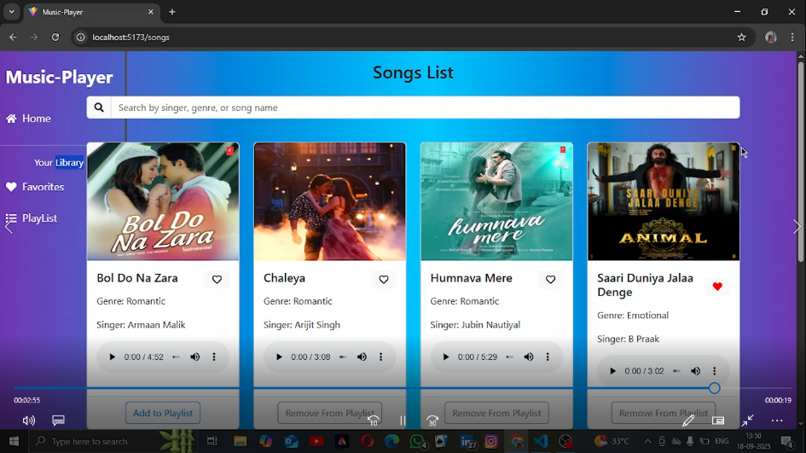

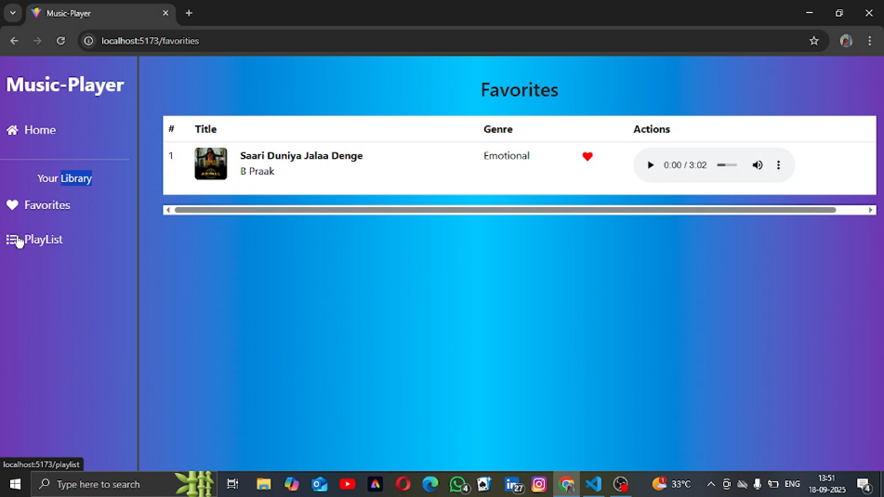

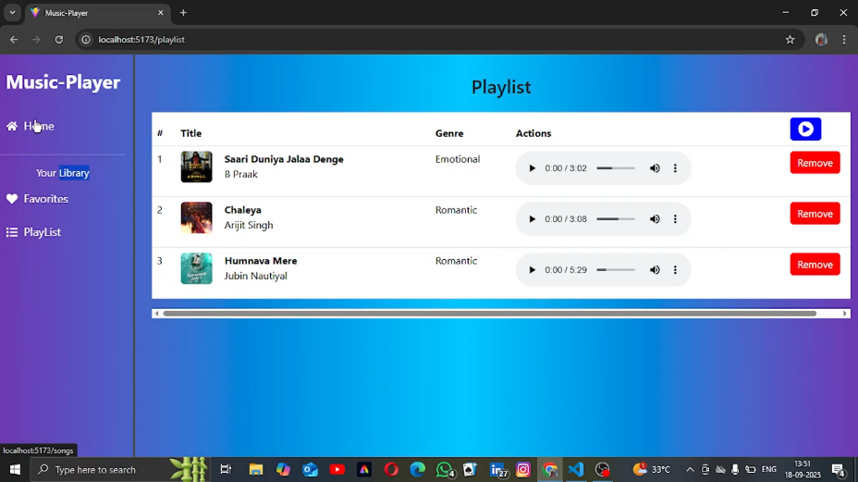

Live Demo Link:

https://github.com/salomi2732006-del/rhythamic-tunes.git

**13. Known Issues**

- Occasional delays in song loading due to API limits

- Playlist feature may require additional optimization for large data sets

**14. Future Enhancements**

- Implement User Authentication for personalized playlists

- Introduce Podcast and Radio Streaming Integration

- Social Sharing Feature for tracks and playlists

- Offline Mode for saved playlists without an internet connection